NAME : SANTHOSH KUMAR R
REG NO : 192512231
SLOT : C
COURSE CODE: ECA0303
COURSE NAME : SIGNAL & SYSTEM

EXPERIMENT -1
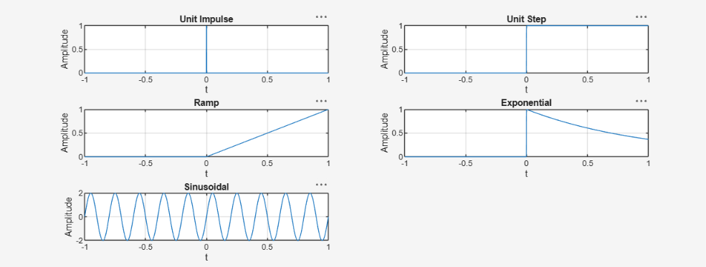
EXPERIMENT -2
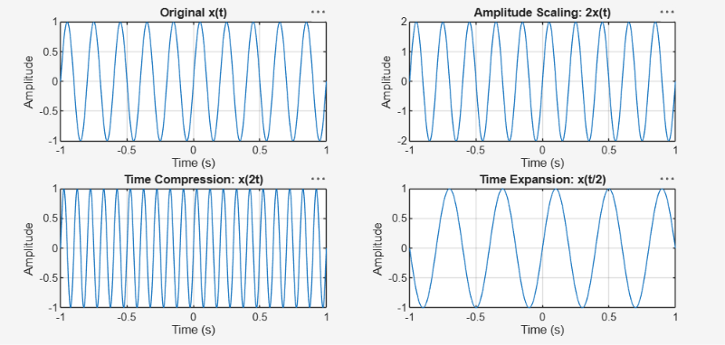

EXPERIMENT -3
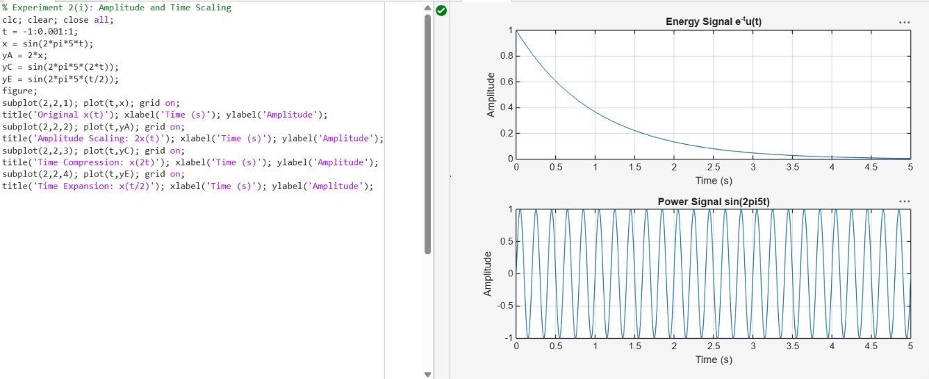
EXPERIMENT – 4
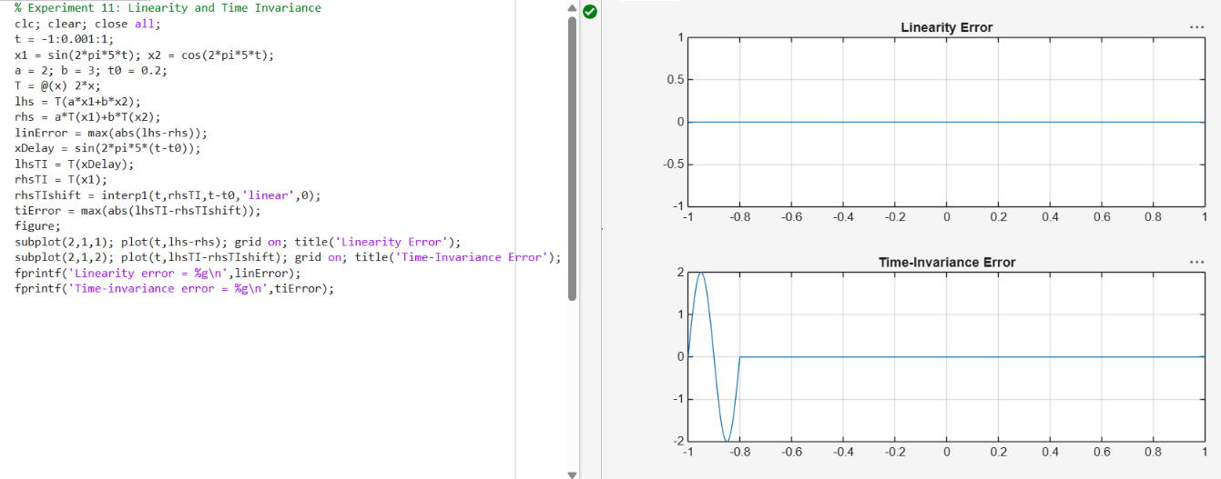
EXPERIMENT – 5
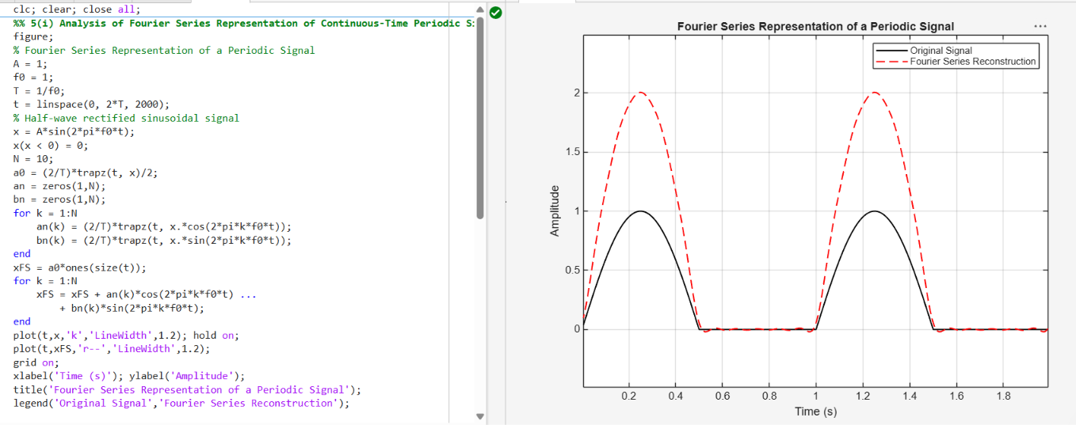

EXPERIMENT – 6
